HW2 Yuan Qin

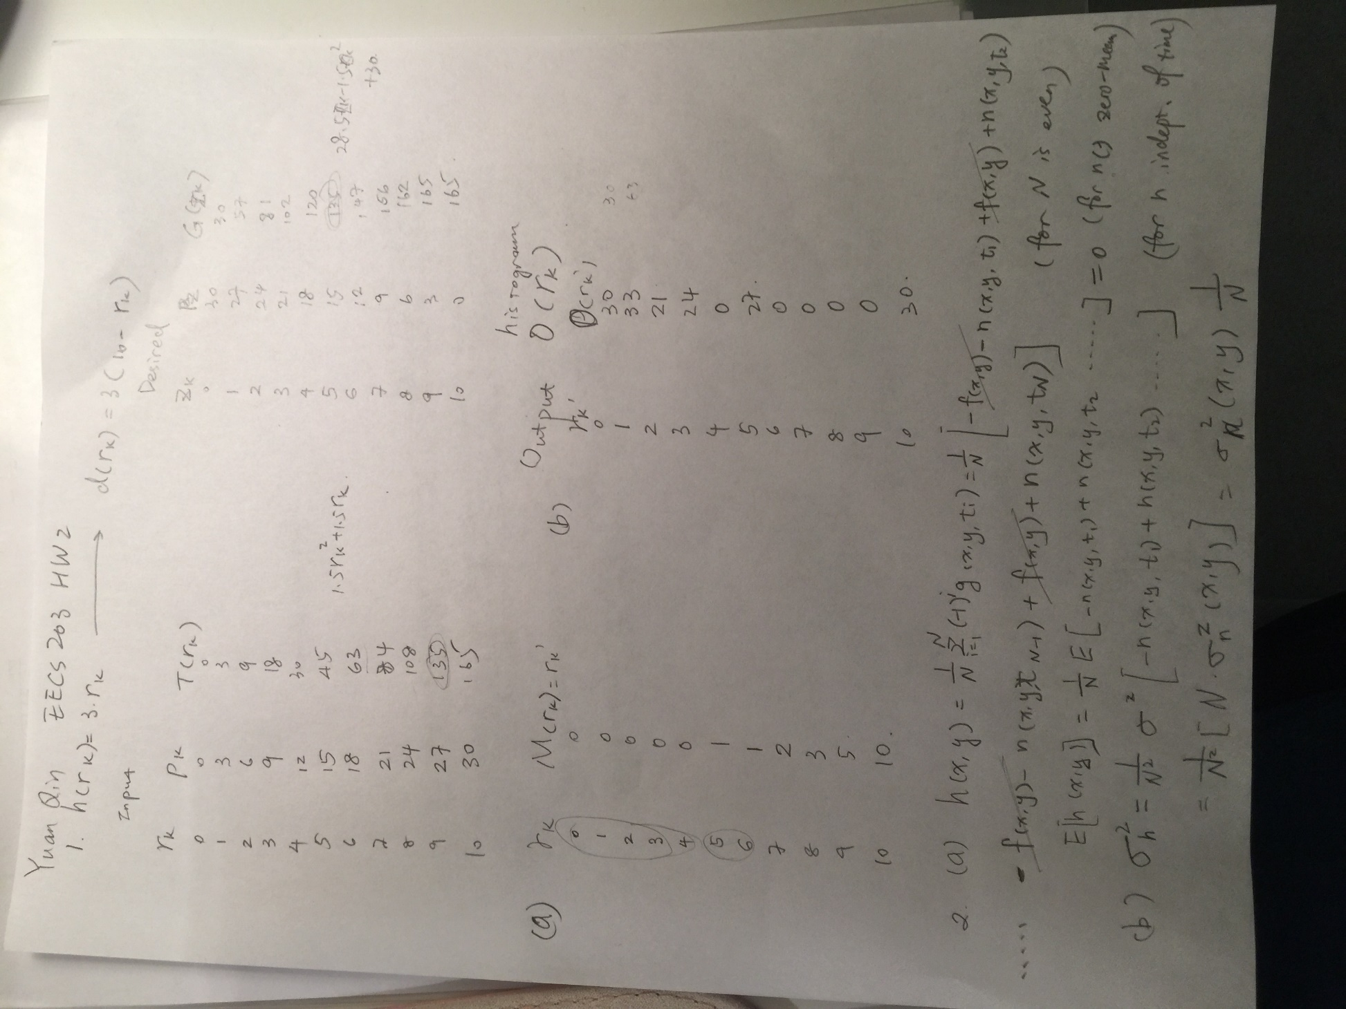

Computer Problem：

1. Power gray level transform curve:

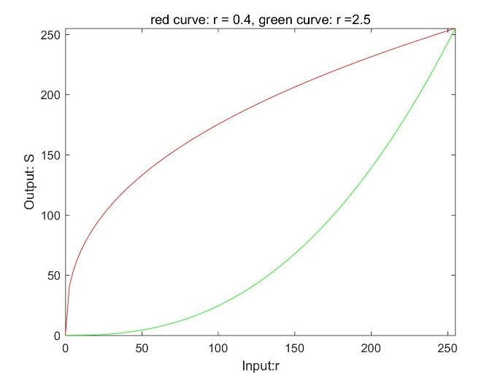

When r = 0.4, the image becomes brighter, while r=0.5 makes the image become darker

R = 0.4 r=2.5

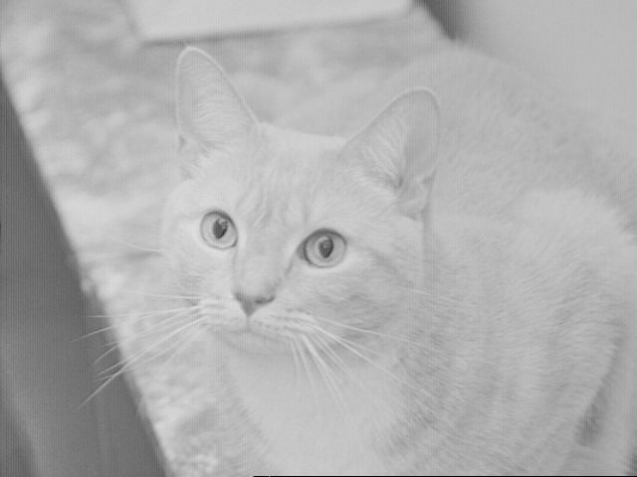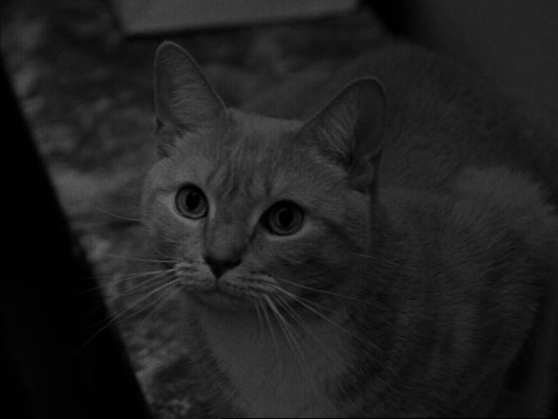

1. The histogram equalization transformation increased the image’s contrast level, and the image is a bit brighter than original

Histogram equalization: Original:

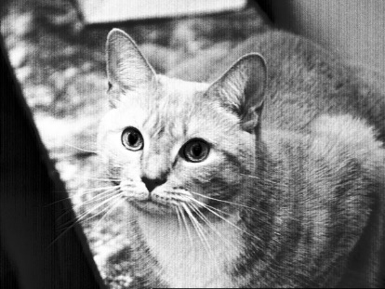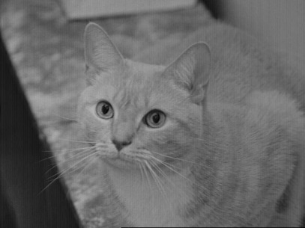

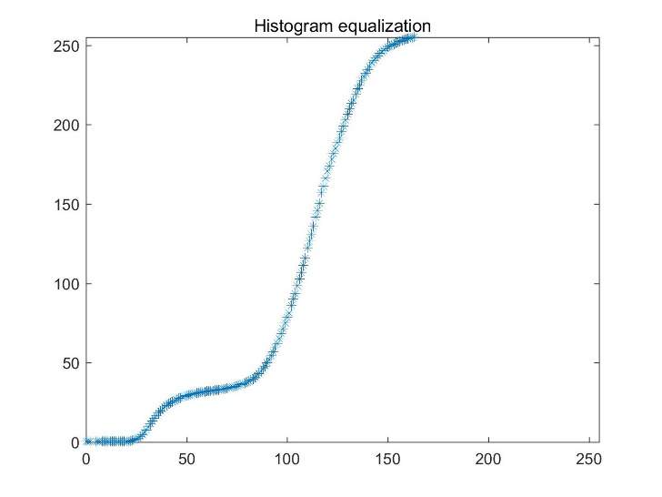x-input, y-output